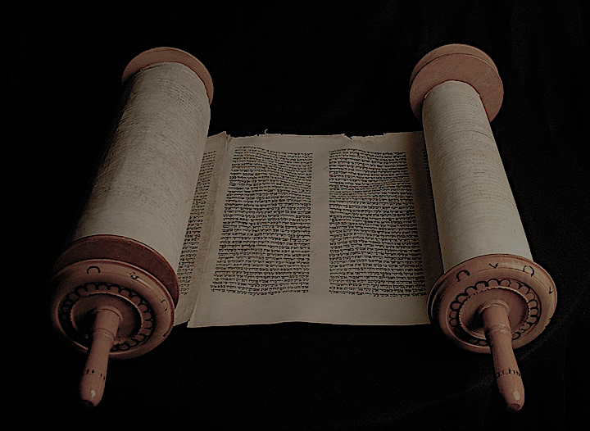
The
Minor Prophets

Introduction to the Minor Prophets
The Twelve

These prophetic messages were given to declare to God’s people his judgement for their faithlessness to the covenant with him. This judgment was not without reprieve however, as God promised restoration and redemption all throughout. The messages of the prophets were carefully constructed into one book and individual messages were orchestrated by God to produce one wholistic message throughout them all.

The timeline of the twelve are all set within a 350-400 year period stretching from between 800 BC to about 400 BC. The nation of Israel had split into two kingdoms; the Northern Kingdom of Israel comprising of 10 tribes, and the southern kingdom of Judah comprising of Judah and Benjamin. The prophets served as God’s messengers, speaking on behalf of the Lord to his people to these two nations, and to surrounding nations as well.

Themes that we will see through this study show us
(a) God’s love for Israel, and the horrendous nature of sin
(b) God’s Covenantal Commitment to Israel
(c) The necessity for God’s people to reflect God’s character
(d) Future judgment of the wicked and salvation for the righteous
(e) How God brings about that Salvation in the promise of a new kingdom.

The goal of this survey of the Minor Prophets: Understand better the historical context, central message and timeless truths that we can apply or hold on to in our lives today.

Hosea

Historical Setting: Between 750-720 BC at the end of Israel’s “Golden Age” under the rule of King Jeroboam II, leading up to the Assyrian conquest of the Northern Kingdom.

Central Message: God has a case against Israel. They have broken their covenant with him, been unfaithful and rejected his love. Hosea is calling them to return to God!
Despite Israel’s Faithlessness, there is hope for Salvation because of God’s redemptive plan of Salvation

Outline:
Hosea 1-3 – The Message on Display

- Hosea’s Marriage to Gomer, the prostitute who was unfaithful to him illustrating Israel’s relationship with the Lord and his faithfulness to Israel (1:1-3:5).
- The name of Hosea’s Children:
  - Jezreel – an indictment for the sins of Ahab, Jezebel, Jehu and Israel.
  - Lo-Ruhamah – Not Loved: God’s judgment is imminent.
  - Lo-Ammi – Not My People: God bringing judgment on his people.

Hosea 4-14 – Israel’s Indictment, Punishment and Restoration

- God’s Love Challenged by Sin – The Indictment (4:1-7:16)
- God’s Coming Judgment – Punishment (8:1-10:15)
- God Gives Hope for Future – Restoration (11:1-14:9)

Themes: The horrifying effects of sin and breaking covenant with God. God’s Love, Mercy and Compassion for his People.

Timeless Application: We know the blessing of a relationship with God through Christ, but we don’t want to miss the warnings and indictments that were brought against Israel. Even though we may not have physical idols that we worship, what do we idolize in our hearts? What do we count on to bring us food, clothing and shelter? What areas of life, what parts of our hearts, what sin struggles do we not submit to the Lord, and in so doing commit adultery and act unfaithfully to the Lord?

Hosea’s call is for faithfulness to the Lord, to recognize the importance living in obedience to the Lord an reflecting the character of God

Joel

Historical Setting: There is some debate about this, but probably after the Babylonian Exile during the Persian Rule around 500 BC

Central Message: The Day of the Lord is at hand. Repentance is the only hope. God will be a refuge for his people, but will devour those who do not heed his voice.
Outline:
Joel 1 – The Locust Plague
  - Description of the current plague
  - Call to Lament the Lost Sacrifices
  - The Day of the Lord is near: Plague as Judgment
Joel 2 – The Increased Judgment (2:1-27)
  - Description of worse judgment to come (2:1-11)
  - Call to repentance to prevent (2:12-17)
  - The Day of the Lord Postponed: Renewed Prosperity (2:18-27)
Joel 3 – The Coming Day of the Lord (2:28-3:20)
  - Description of the Day of the Lord (2:28-32)
  - Judgment on the Nations (3:1-17)
  - Prosperity of Israel (3:18-20)

Themes: The Judgment of God: The Day of the Lord – Judgment initially directed toward Israel. Salvation through repentance, and judgment toward the nations. The loss of sacrifices.

Timeless Application: How does future judgment affect the way we live today?
Joel’s instructions for how to respond to the judgment of God are clear. Weep and lament over sin, repent of sin, and rejoice in the salvation of God.

